Configure setup:
Create the network in VirtualBox: 172.16.96.0/24
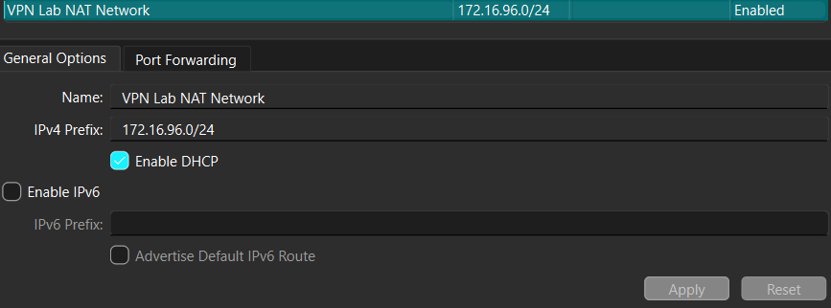
Add the machines to the network (Ub1, Ub2 and Kali):
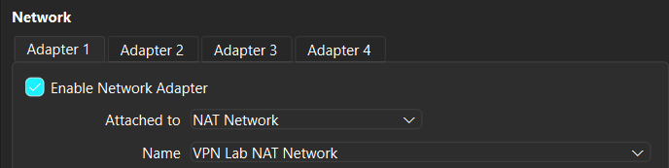
The ips are:
172.16.96.3/24 -> Kali (Server) (stud-stud)
172.16.96.4/24 -> Ubuntu1 (Client) (student-student)
172.16.96.5/24 -> Ubuntu2 (Client) (student-student)

Server: Necessary files
File | Purpose
server.conf | Main OpenVPN server configuration file
server.crt | Server certificate (signed by CA)
server.key | Server private key
ca.crt | Certificate Authority certificate (used to verify clients)
ta.key | TLS authentication HMAC key (same key shared with clients)
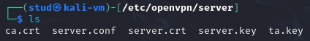
server.conf:
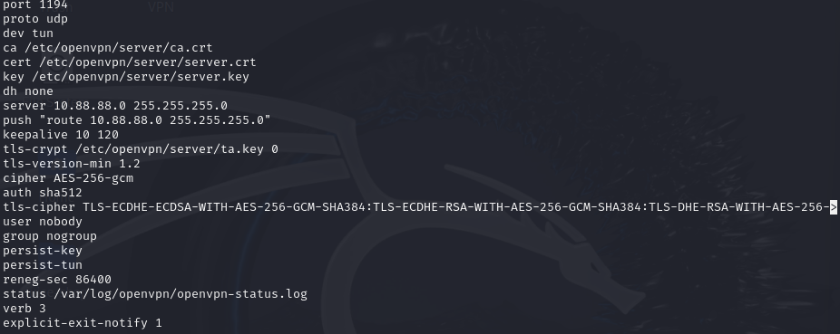
Start the server: > sudo systemctl start openvpn-server@server.service
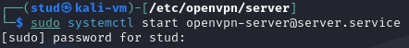
To check status: > sudo systemctl status openvpn-server@server.service
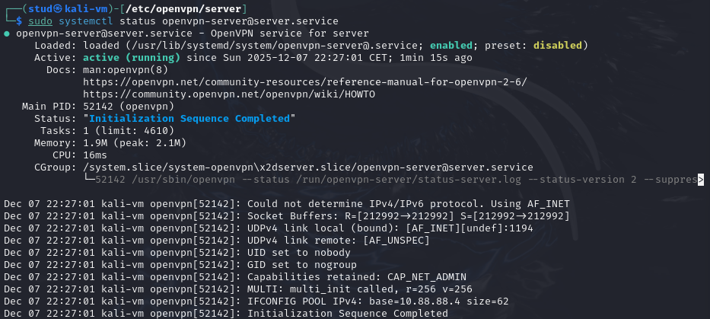

Client: Necessary files
File | Purpose
client.ovpn | Main OpenVPN client configuration file
clientX.crt | Client certificate (client1.crt or client2.crt)
clientX.key | Client private key (client1.key or client2.key)
ca.crt | CA certificate (same as server, to verify server identity)
ta.key | TLS authentication HMAC key (same as server)

Client1:
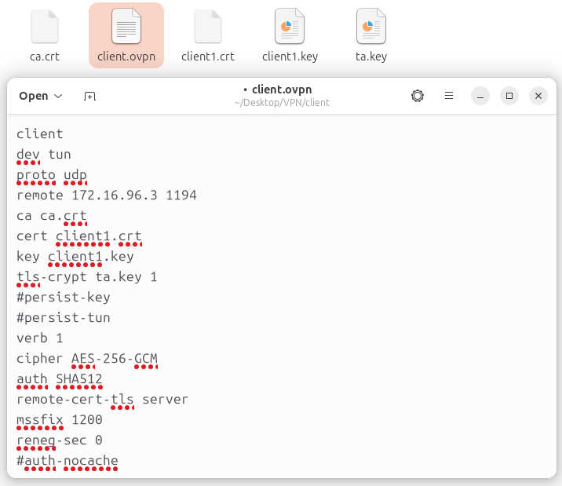
Start connection: > sudo openvpn --config /home/student/Desktop/VPN/client/client.ovpn
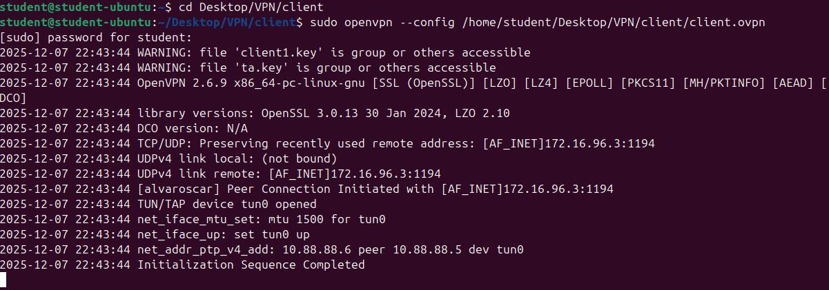
Client2:
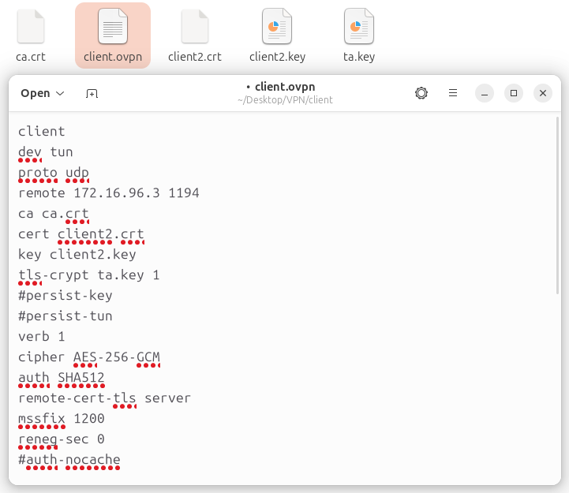
And start connection:
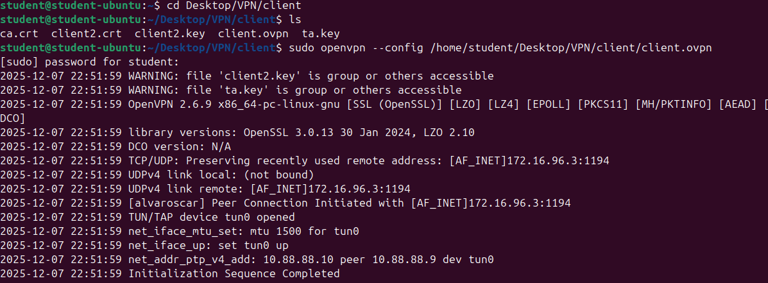

TLS communications:
The point aims to analyze the TLS 1.2/TLS 1.3 communications. Get acquainted with TLS/SSL versions 1.2 and 1.3, find the advantages and disadvantages of each version.

Capture the network traffic on the physical network interface (usually, the name starts with en…):
Physical Network: eth0
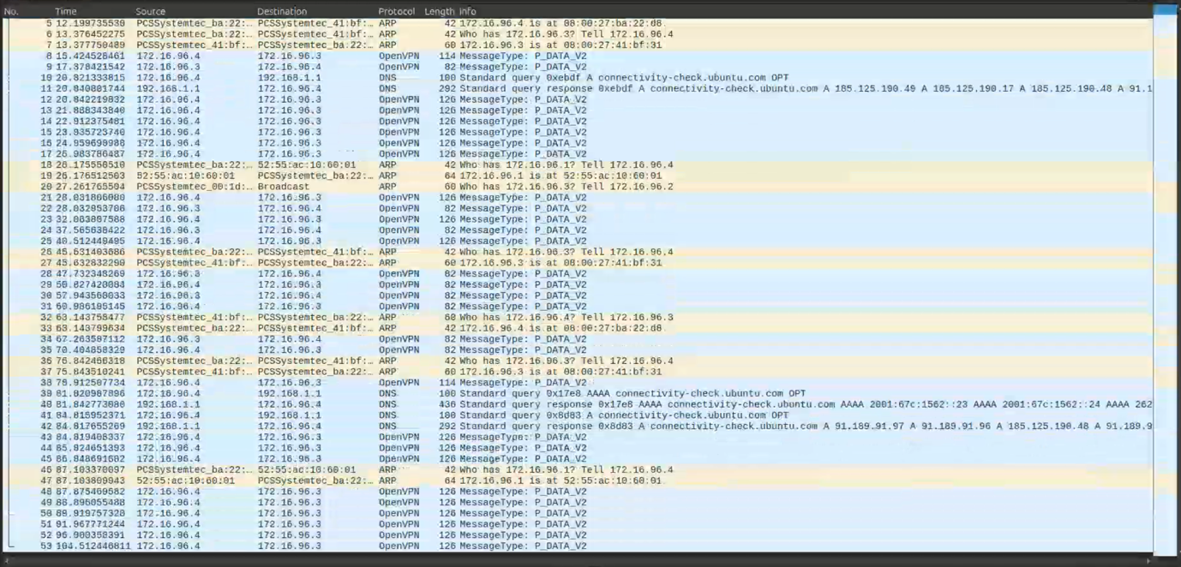
In the network capture taken on the physical network interface, most of the packets are identified as OpenVPN traffic (e.g., MessageType: P_DATA_V2). This behavior is expected when the client is actively connected to the VPN. Once the VPN tunnel is established, all outgoing and incoming traffic from the system is encapsulated inside the encrypted OpenVPN tunnel before it is transmitted over the physical interface.
For this reason, the physical interface does not display the original application-layer traffic (such as HTTPS/TLS handshakes, HTTP requests, or any plaintext data). Instead, it only shows the encrypted VPN packets that transport internal communication. The content of these packets cannot be inspected, as OpenVPN encrypts the payload using the configured cipher and authentication algorithms.
Additionally, some DNS queries (e.g., connectivity checks from Ubuntu) and ARP messages may appear in the capture. These packets are generated by the operating system for normal network operation and are not part of the VPN’s encrypted payload. They are visible because they occur outside the VPN tunnel

Filter only the records for TLS/SSL communication. Filter expression for TLS/SSL in Wireshark: ssl.record.version == 0x0303
When the TLS/SSL filter is applied in Wireshark (e.g., ssl.record.version == 0x0303), the capture initially shows no traffic. This occurs because, while the VPN is active, all outgoing data—including TLS sessions—is encrypted and encapsulated inside OpenVPN packets before reaching the physical network interface. Since the TLS traffic is hidden inside the VPN tunnel, Wireshark cannot detect or classify these packets as TLS, and the filter returns an empty result.
However, once a web browser is opened and an HTTPS request is made, and the correct filter (tls) is applied on the appropriate interface, the capture begins to display TLSv1.2/TLSv1.3 handshake messages, such as Server Hello, Certificate, Key Exchange, and later Application Data, which represents encrypted HTTP content. This filtered traffic corresponds to the actual TLS communication generated by the browser during the secure web session.
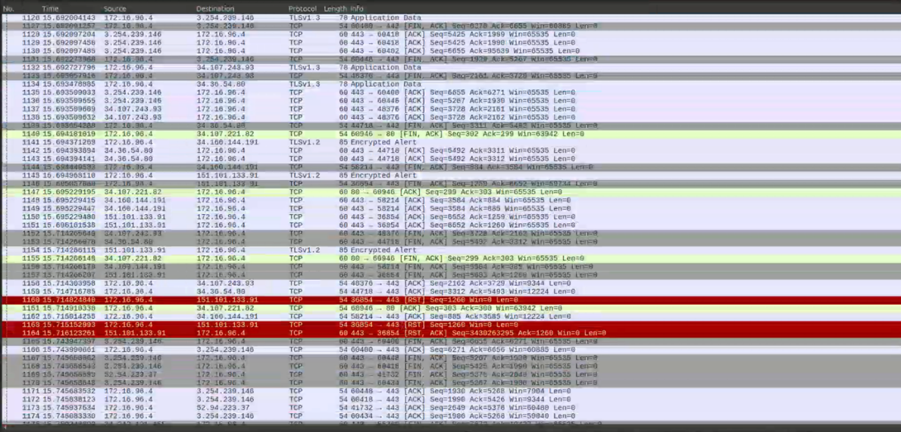
And filtered: 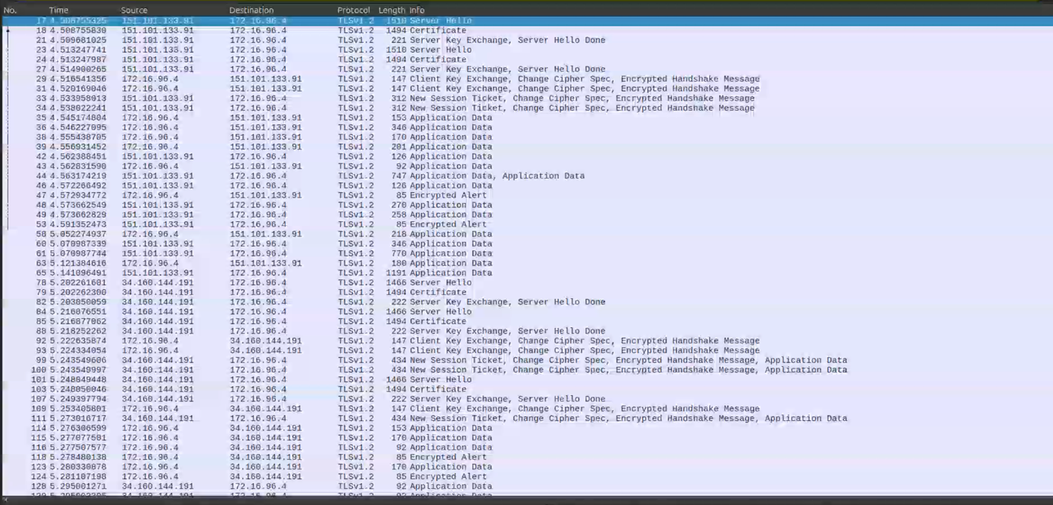
In summary, no TLS packets appear at first because the VPN hides them inside encrypted OpenVPN data, but TLS records become visible when the browser performs an HTTPS request and the filter is applied on the interface carrying the TLS traffic directly.

Study the TLS/SSL records in detail:
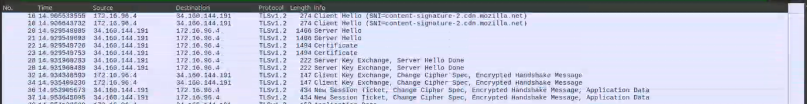
The captured TLS/SSL records show the complete sequence of messages exchanged during the TLS 1.2 handshake between the client and the server. The handshake begins with the Client Hello, where the client indicates supported cipher suites and includes the Server Name Indication, revealing the intended host. The server responds with a Server Hello, selecting the protocol parameters, followed by the Certificate message containing the server’s public key.
Subsequently, the Server Key Exchange and Server Hello Done messages finalize the server’s part of the negotiation. The client then sends its Client Key Exchange, followed by the Change Cipher Spec and Encrypted Handshake Message, indicating that all further communication is now encrypted. Finally, the server sends a New Session Ticket and its own Change Cipher Spec and encrypted handshake confirmation.
After the handshake completes, the capture shows Application Data packets, which represent encrypted HTTP traffic exchanged over the established TLS session. The contents of these packets cannot be read, demonstrating the confidentiality provided by TLS.

Is TLS and SSL the same protocol?
No, TLS and SSL are not the same protocol. TLS is the newer, improved, and more secure version of SSL. Although TLS was originally based on SSL, the SSL versions are now considered outdated and insecure, while TLS is the current standard for encrypted communication.

What is a TLS/SSL handshake?
A TLS/SSL handshake is the initial negotiation process between a client and a server that establishes a secure connection. During the handshake, both parties agree on the encryption algorithms, exchange keys, verify the server’s identity, and create the session keys that will be used to encrypt the data.

What does the TLS/SSL protocol provide, give examples of its applications (at least 2)?
TLS/SSL provides confidentiality, integrity, and authentication for data transmitted over a network. It ensures that the communication is encrypted, cannot be modified, and that the client can verify the identity of the server.
Common applications include:
- HTTPS for secure web browsing.
- Secure email protocols such as SMTPS, IMAPS, or POP3S.
- VPNs and other secure remote access technologies.

Which versions of the protocol are currently the most popular?
The most commonly used and widely supported versions today are TLS 1.2 and TLS 1.3. TLS 1.3 is the newest and most secure version, but TLS 1.2 is still widely used for compatibility with older systems.

Which version offers higher security and why?
TLS 1.3 offers higher security because it removes outdated and vulnerable cryptographic algorithms, reduces the number of handshake messages, encrypts more parts of the negotiation, and improves protection against attacks such as downgrade and replay attacks.

Which version offers higher performance?
TLS 1.3 offers higher performance because it uses a faster handshake with fewer round-trips and more efficient cryptographic algorithms. This reduces latency and speeds up the establishment of secure connections compared to TLS 1.2.

Based on the traffic captured, analyze the recorded TLS/SSL traffic:

Which version of the protocol has been captured?
The captured traffic shows TLS 1.2 communication. This is visible in the Wireshark records, where several packets are labeled as TLSv1.2, including messages such as Server Hello, Certificate, Server Key Exchange, Change Cipher Spec, and Application Data. These are characteristic of a TLS 1.2 handshake.
If the connection were using TLS 1.3, the handshake would look very different. TLS 1.3 only exposes the Client Helloand Server Hello messages, while all other handshake steps (key exchange, authentication, and session establishment) appear as “Encrypted Handshake Message”. TLS 1.3 does not show Server Key Exchange or Change Cipher Spec, as these elements were removed from the protocol.

What kind of messages does a handshake consist of (connection establishment)?
A TLS 1.2 handshake consists of several messages exchanged between the client and the server to negotiate security parameters and establish an encrypted session. In the captured traffic, the handshake includes:
- Client Hello: the client proposes supported TLS versions and cipher suites.
- Server Hello: the server selects the protocol parameters.
- Certificate: the server sends its certificate for authentication.
- Server Key Exchange: the server provides key exchange information.
- Server Hello Done: indicates the server has finished its part of the negotiation.
- Client Key Exchange: the client sends key material to establish the session key.
- Change Cipher Spec: the client and server switch to encrypted communication.
- Finished / Encrypted Handshake Message: confirms that the handshake is complete.

These steps complete the establishment of a secure TLS session.

What does the version of the protocol use depend on?
The version of the TLS protocol used depends on several factors:
- The client’s supported TLS versions (listed in the Client Hello).
- The server’s supported versions, which determine the highest version both sides can use.
- Security policies or configuration settings on either side, which may disable older or insecure versions.
- The cipher suites available, since some are only compatible with specific TLS versions.
The final protocol version is the result of the negotiation between client and server during the handshake.

Take a print screen of what type of encryption was used for encryption and put it into the report.
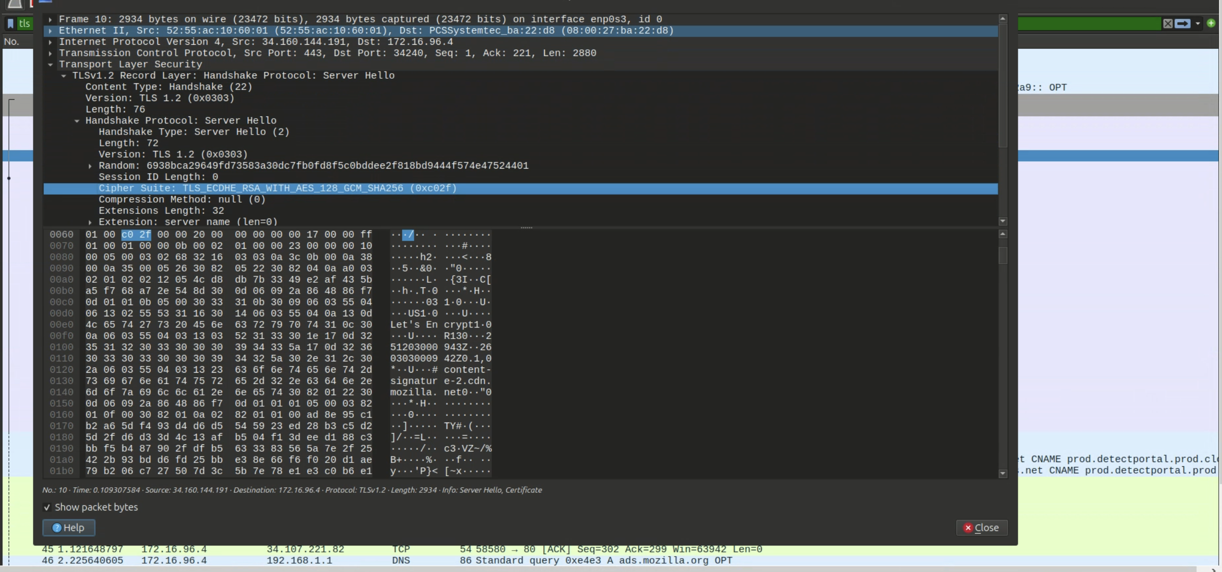

OpenVPN Part-1:

Capture the network traffic on the VPN network interface (usually, the name is tun0, check it using ifconfig command):
In Kali (Server) we start the connection (tun0):
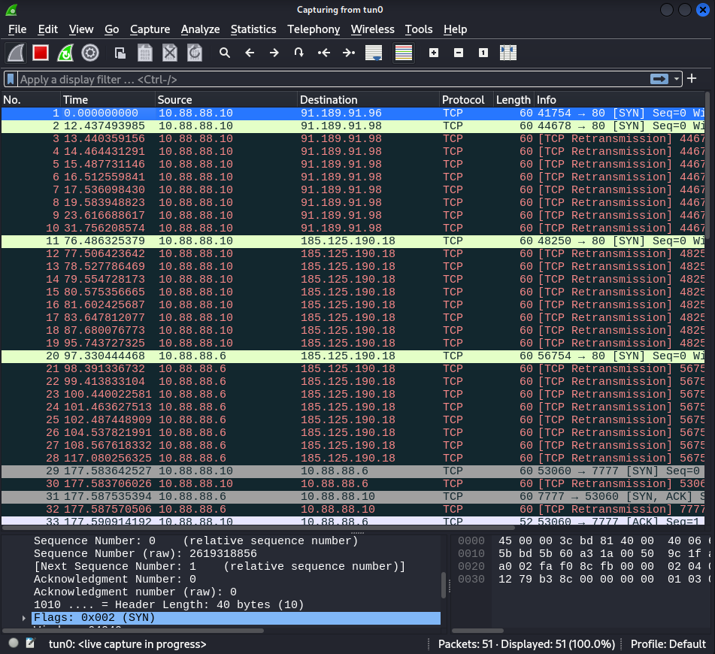

Send a few messages using netcat between clients A and B:
Client B: > nc -l -p 7777
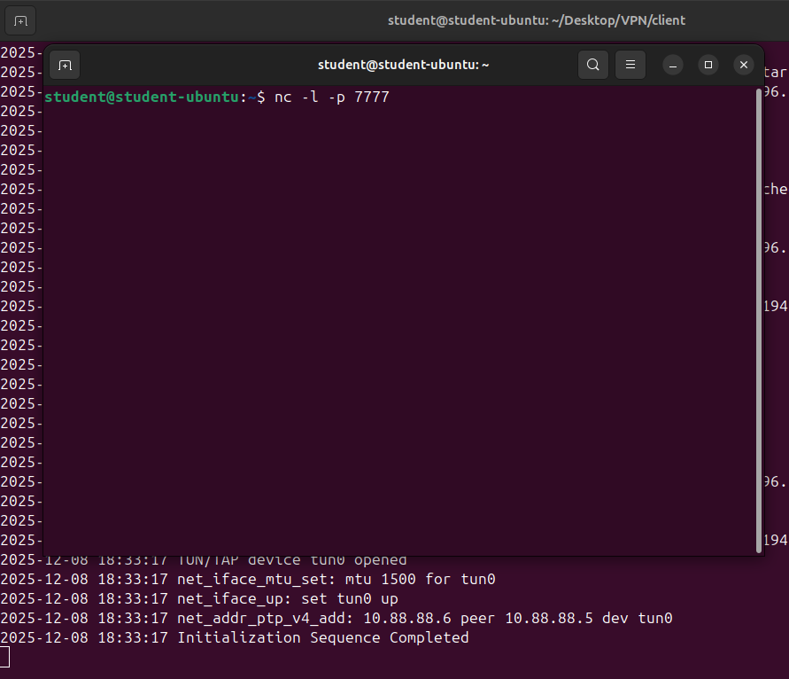
Client A: > nc X.X.X.X 7777 (Where X.X.X.X is clientA ip on the VPN network)
And write some text in any of both terminals:
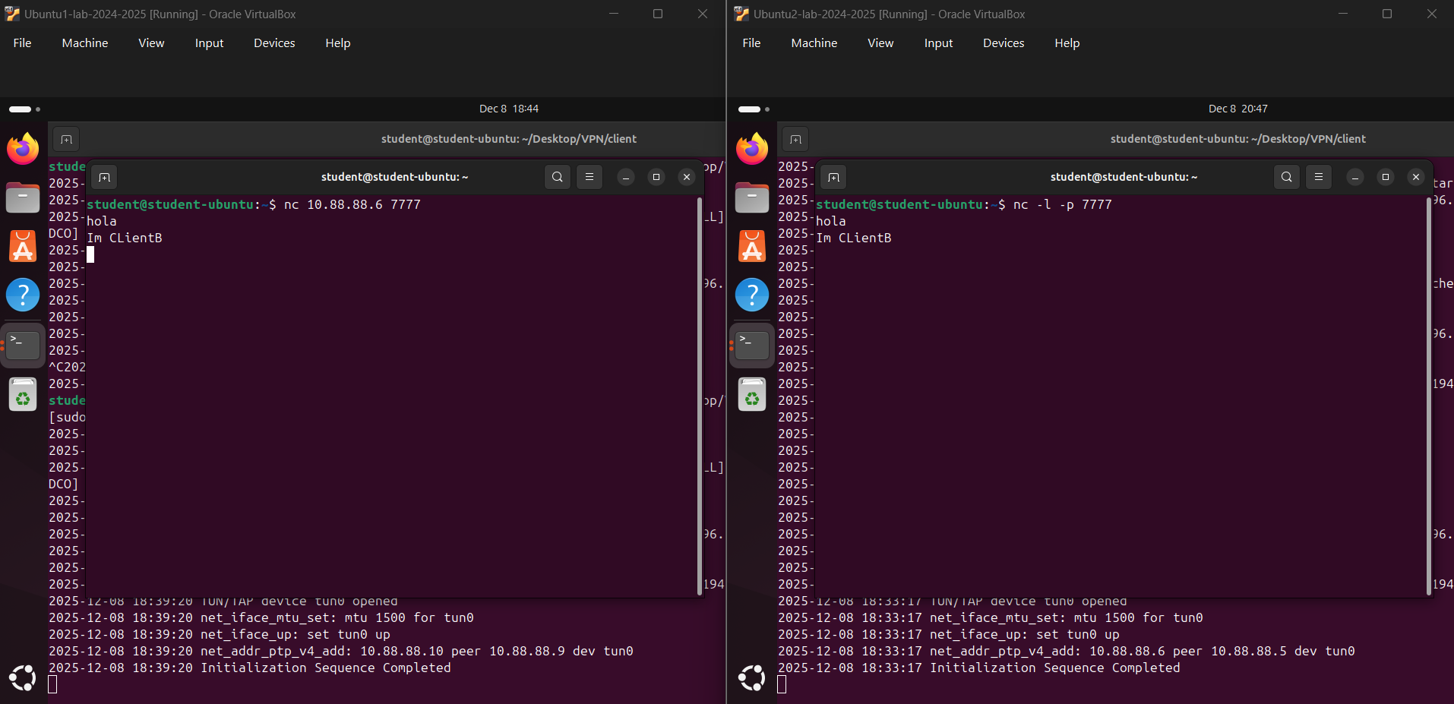

Observe and analyze the communication process and it is content in the WS:
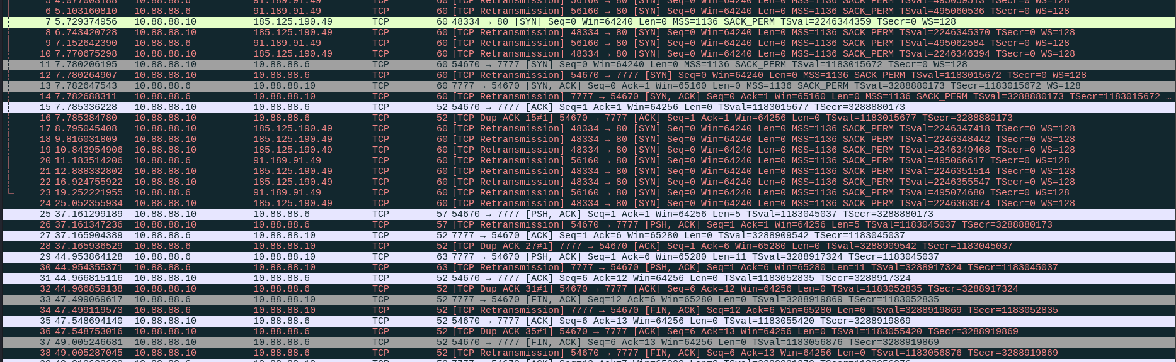
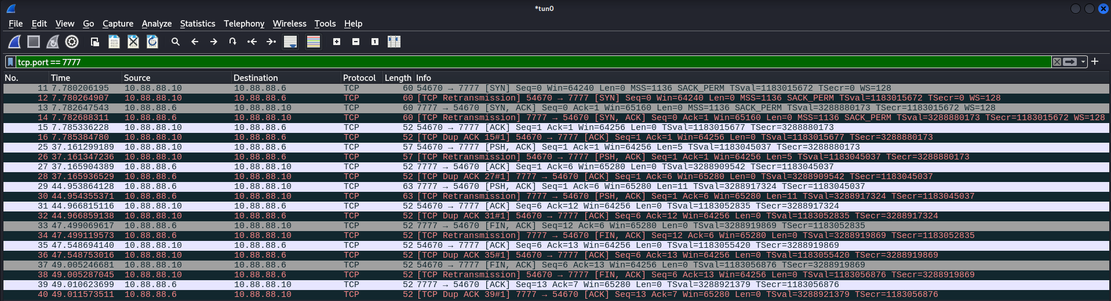
We can analyze in Wireshark given the known port 7777, apply the filter > tcp.port == 7777
I could see TCP packets between the VPN addresses 10.88.88.6 (client A – Ubuntu1) and 10.88.88.10 (client B – Ubuntu 2), using destination port 7777.
This confirms that the captured traffic corresponds to the netcat communication inside the VPN tunnel.

Find and verify the data sent by netcat in the WS. Is it possible to read the message that was sent by netcat? Take a print screen of the data contained in the packets:
By selecting one of the TCP packets (EX: 25) with payload (Flag [PSH, ACK]) and expanding the Data section in Wireshark, you can see the massage sent via netcat (“hola”).
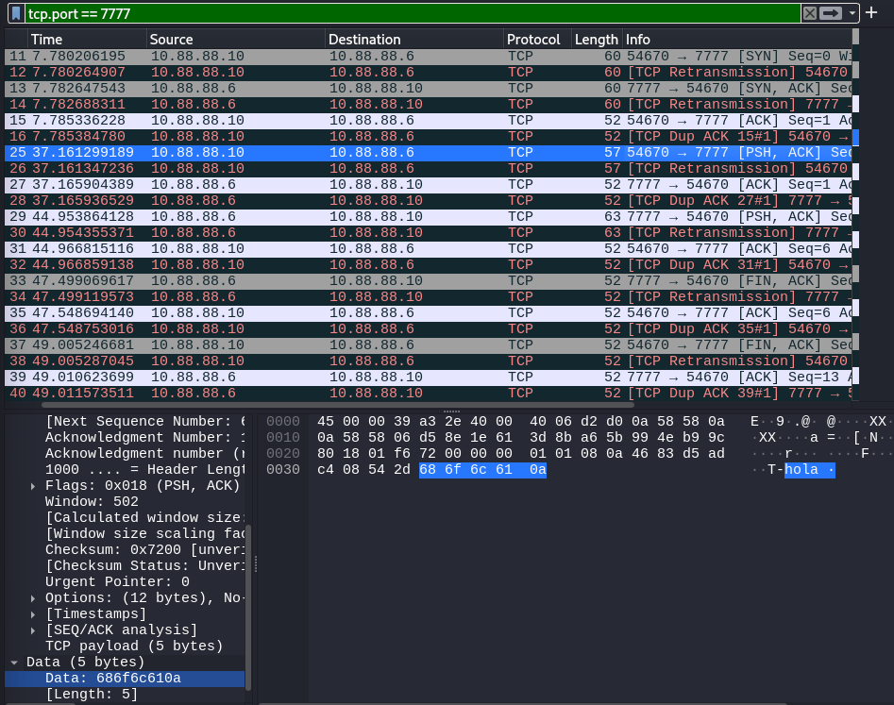

Also, the second message is in frame 29 so we can see its content (“Im ClientB”):
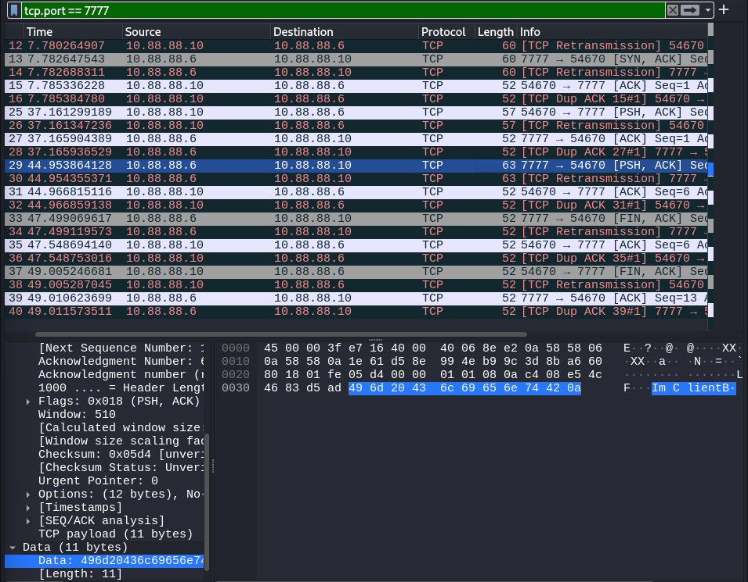
Therefore, it is possible to read the message sent by netcat as they are not cyphered at this point when capturing on the VPN interface tun0, because the traffic is already decrypted through the server network.

OpenVPN Part-2:

Capture the network traffic on the physical network interface (usually, the name starts with en…):
In Kali (Server) we start the connection (eth0):
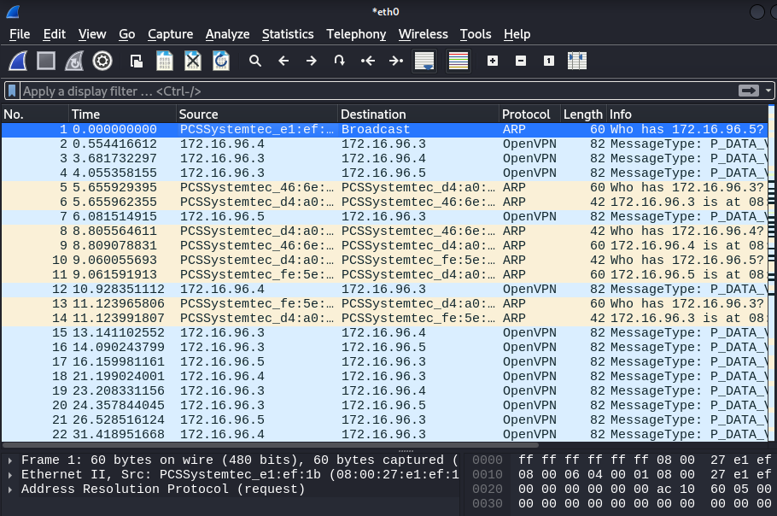

Send a few messages using netcat between clients A and B:
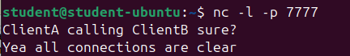
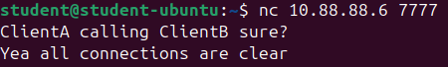

Observe and analyze the communication process and it is content in the WS:
We apply the filter to only register messages of Client A (172.16.96.4) and Client B (172.16.96.5):
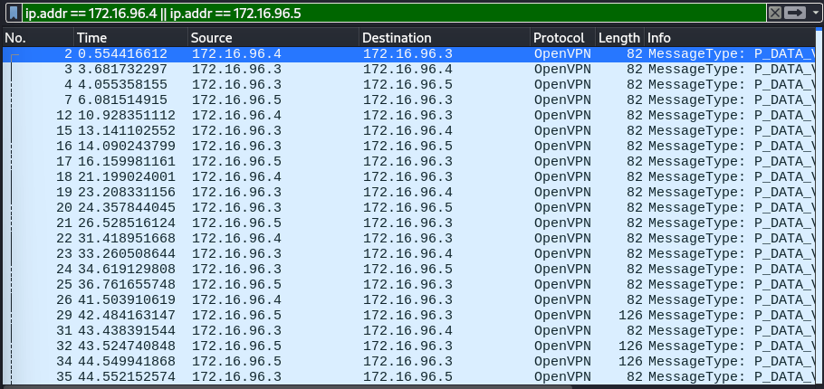
As we can see, all packages pass through the VPN server (172.16.96.3).

Find and verify the data sent by netcat in the WS. Take a print screen of the data contained in the packets:
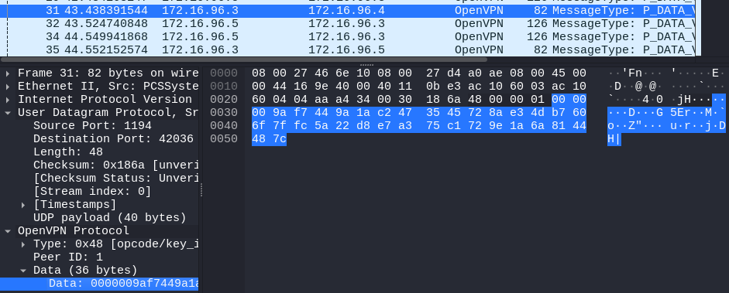
As the data is encrypted through the network thanks to the VPN, no critical data is shown in Wireshark.
So, through the eth0 / enp0s3 network that is the 172.16.96.0/24 network the data is encrypted.

Questions to task 2 and 3:

Is it possible to read the message that was sent via netcat?
- tun0 (Task 2): Yes, as the tunnel terminates and decrypts the traffic, so Wireshark captures TCP between 10.88.88.6 and 10.88.88.10 on port 7777 and the netcat message is visible as plain text in the Data field.
- enp0s3 (Task 3): No, as the packets are OpenVPN UDP/1194 between 10.0.2.3 and 10.0.2.5 and their payloads are encrypted, so the netcat message cannot be read.

What is the characteristic of captured traffic on the VPN network interface and the host interface?
VPN interface (tun0):
- Source and destination IP addresses correspond to the VPN-assigned addresses (10.88.88.x).
- The protocol appears as the actual application protocol (e.g., TCP on port 7777 for netcat).
- The payload is visible in clear text because the traffic is already decrypted at this point.
Host/physical interface (enp0s3 / eth0):
- Source and destination IP addresses are the real network addresses of client A and server (10.0.2.4 <-> 10.0.2.3) or client B and server (10.0.2.5 <-> 10.0.2.3).
- The observed protocol is OpenVPN encapsulated in UDP source port 1194.
- The payload is fully encrypted, so no application-layer data is visible.

What relevant information can you see analyzing the traffic for both cases?
From the physical interface (enp0s3 / eth0) you observe:
- The existence of a VPN tunnel between the client and the server (traffic between 10.0.2.3:xxxx and 10.0.2.5:1194).
- The volume, direction, and timing of the encrypted packets but no visibility into the application data since the tunnel payload is encrypted.
From the VPN interface (tun0) you observe:
- The VPN-level source and destination addresses of the communicating hosts.
- The application protocol and port being used (such as netcat on TCP 7777).
- The full message contents, which appear in clear text after decryption.

OpenVPN Part-3:

Capture the network traffic on the physical network interface (usually, the name starts with en…):
In Kali (Server) we start the connection (eth0):
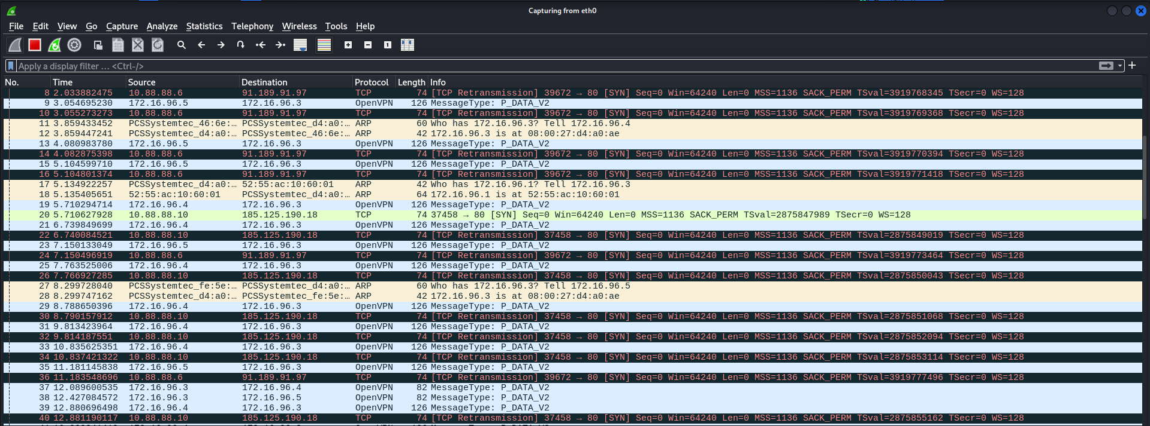

Send a larger file via netcat. The file is located on the client’s VM. (in directory: /home/Ubuntu/Desktop/FILES/ubuntu.iso, ubuntu.iso ~900MB):
We need to write to send the file (“FileToSend.iso” of 627MB):
ClientB: nc -l -p 7777 > FileToReceive.iso
CLientA: cat ./Desktop/ FileToSend.iso | nc 10.88.88.6 7777 (Where 10.88.88.6 is the address of client B)
(As cat writes the data and the pipe inserts it into the connection that clientB receives and converts adds it into the file “FileToReceive.iso”)
To check if it is being sent check Wireshark:
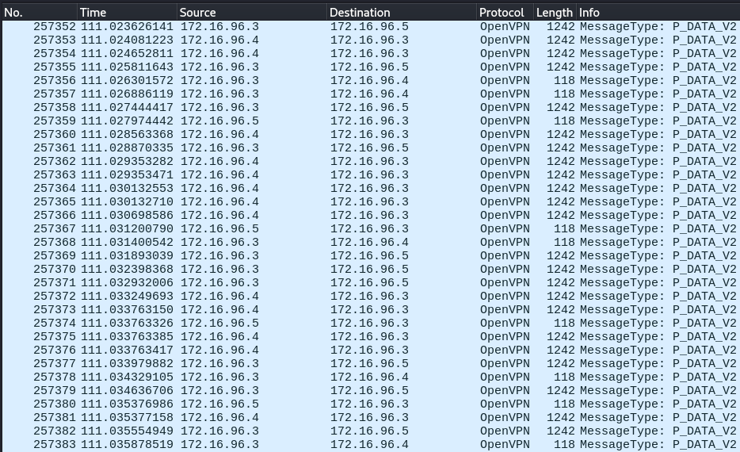
Thousand packages are sent/received so it is working.

Transfer the file 4 times, each time change the encryption and authentication algorithm. Edit client.ovpn for both clients and change the following parameters simultaneously:
By opening Wireshark and checking the frame times we can calculate the duration of the transaction.

Setting 1:

Cipher AES-256-GCM

Auth SHA512,
Packets of 1242 bytes and 118 bytes:
The large ones (1242 B) are the encrypted data itself, and the 118 packages are the confirmations that the data arrived
First Frame Time: 2.48 seconds
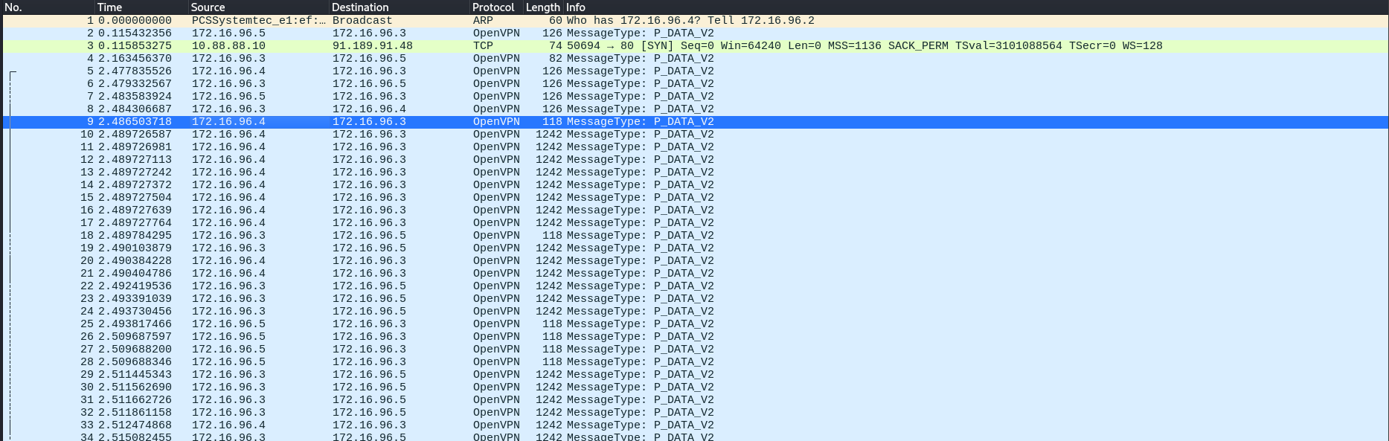
Last Frame Time: 875.4 seconds
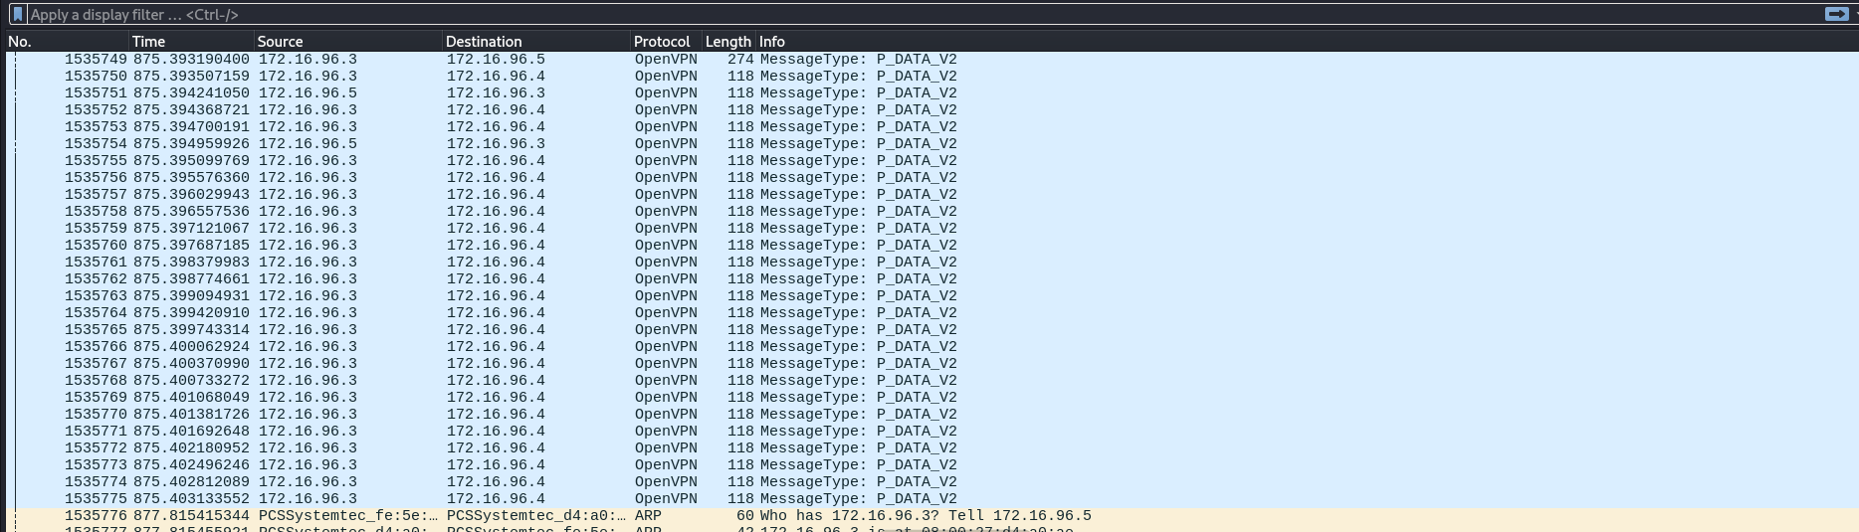
Time it took to move the file: 872.92 seconds
No application-layer data is readable on this interface.

Setting 2:

Cipher AES-128-CBC

Auth SHA1
First Frame Time: 3.29 seconds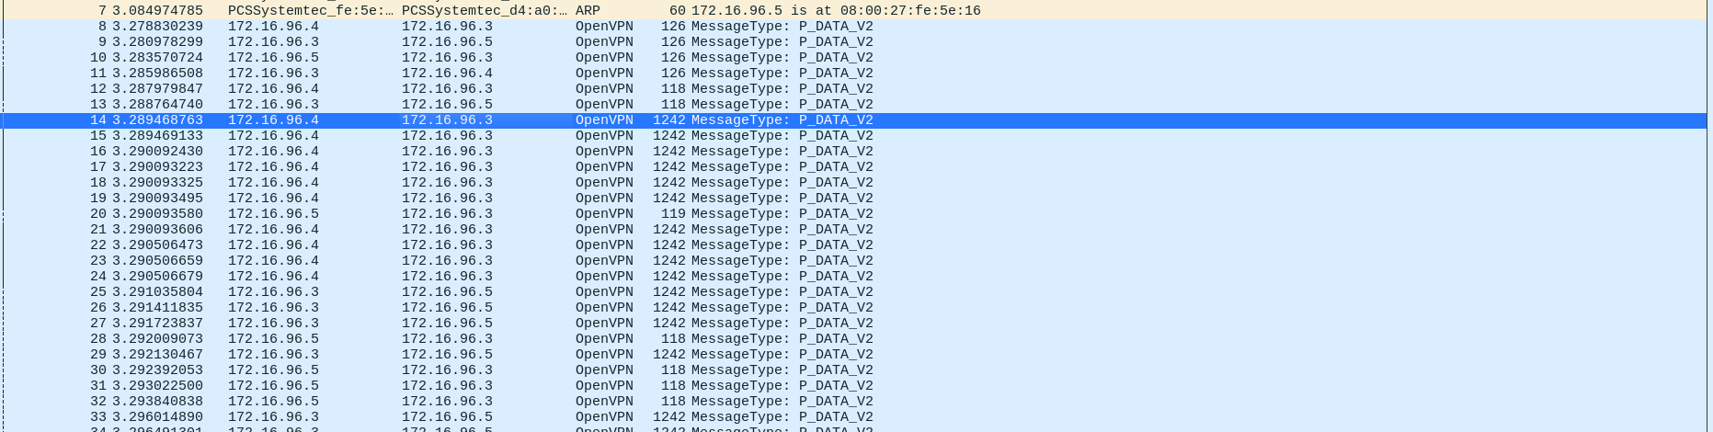
Last Frame Time: 614.19 seconds
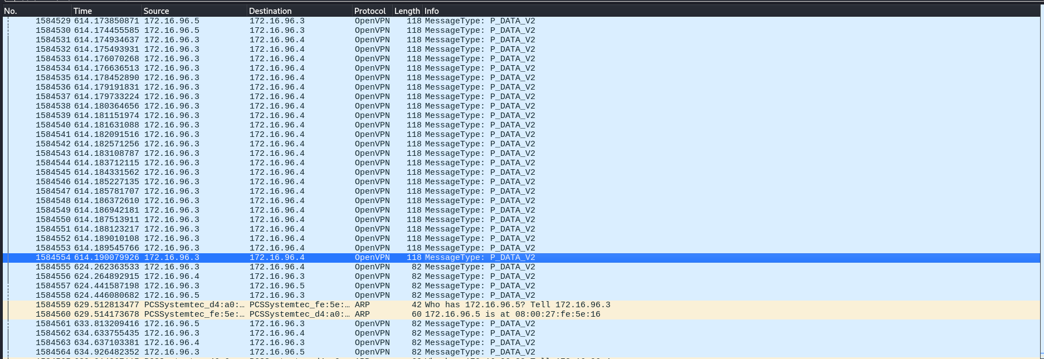Time it took to move the file: 610.9 seconds

Setting 3:

Cipher DES-EDE-CBC

Auth MD5
First Frame Time: 6.69 seconds
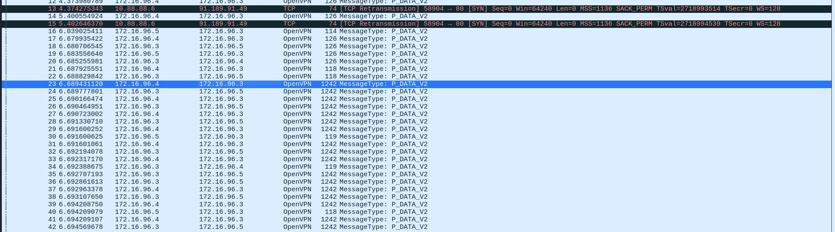
Last Frame Time: 617.92 seconds
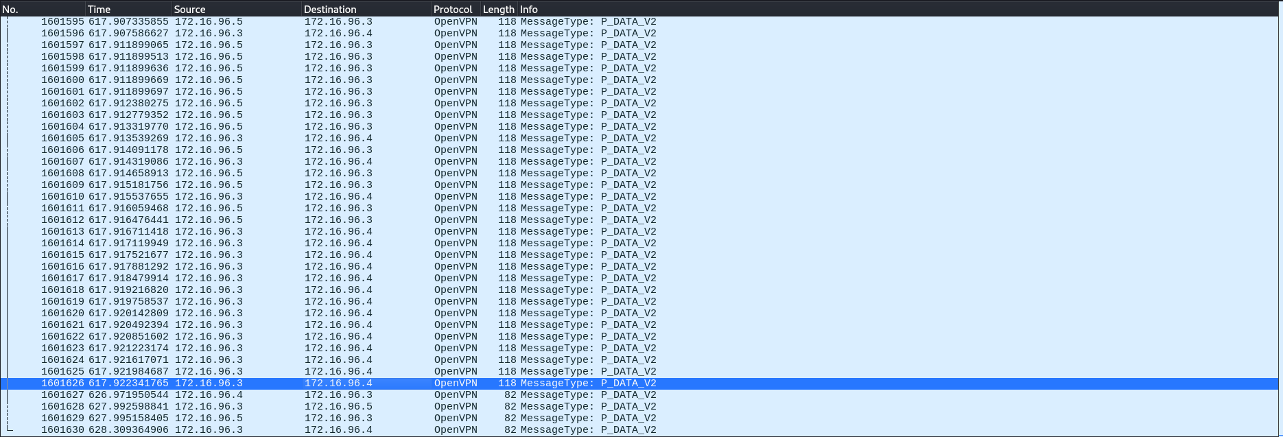
Time it took to move the file: 611.23 seconds

Setting 4:

Cipher DES-CBC (As it is not supported, I changed it to BF-CBC)

Auth MD5
First Frame Time: 5.24 seconds
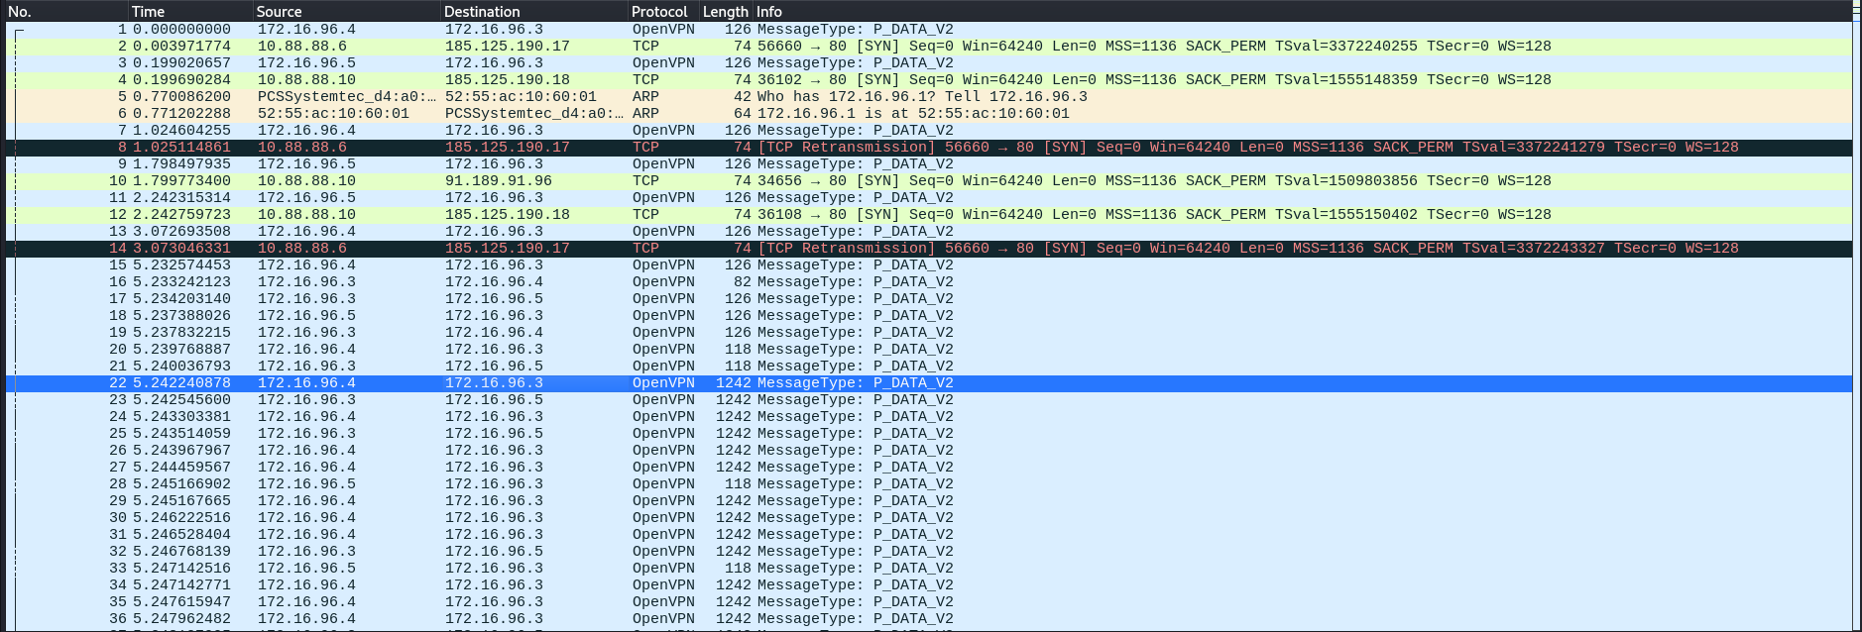
Last Frame Time: 749.78 seconds
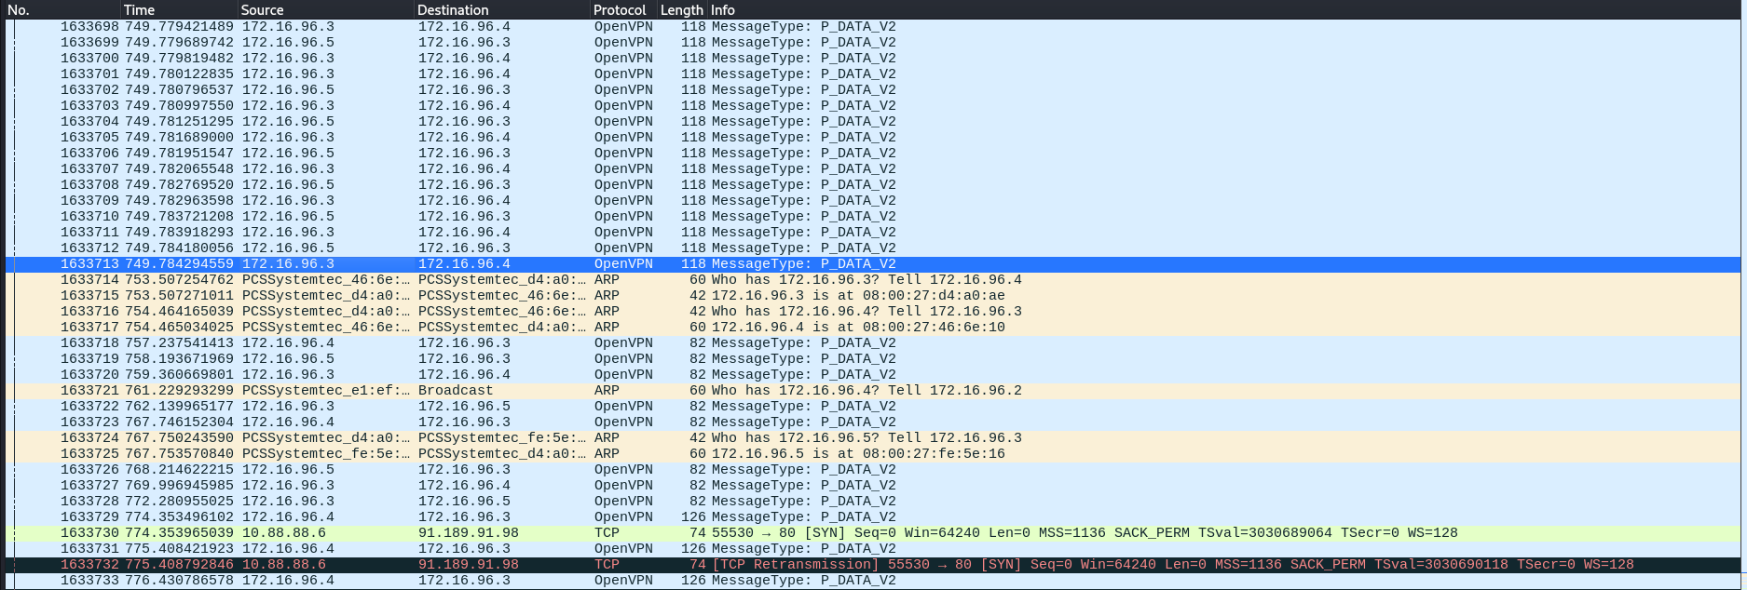
Time it took to move the file: 744.54 seconds

Observe and analyze the communication process and it is content in the WS.

Measure the time of data transfer.
Configuration | AES-256-GCM - SHA512 | AES-128-CBC - SHA1 | DES-EDE-CBC - MD5 | BF -CBC -  MD5
Time (seconds) | 872.92 | 610.9 | 611.23 | 744.54

Is there a difference in data transfer times? What can affect them?
Yes, times differ:
- AES-256-GCM / SHA512 → 872.92 s
- AES-128-CBC / SHA1 → 610.90 s
- DES-EDE-CBC / MD5 → 611.23 s
- BF-CBC / MD5 → 744.54 s
Factors affecting times:
- Cipher computational cost (AES-256 > AES-128 > DES/Blowfish)
- Authentication overhead (SHA512 > SHA1 > MD5)
- Mode differences (GCM vs CBC)
- Packet size, fragmentation, retransmissions
- CPU hardware acceleration, disk I/O, system load

What can we say about the encryption and authentication algorithms used?
AES-256-GCM / SHA512 → Very strong, modern AEAD
AES-128-CBC / SHA1 → Secure cipher, but SHA1 is weak for integrity
DES-EDE-CBC / MD5 → Weak, slow, outdated
BF-CBC / MD5 → Weak, small block size, insecure hash

Which set of settings is the worst and which is the best in terms of security?
AES-256-GCM + SHA512 ✅
AES-128-CBC + SHA1 ⚠️
DES-EDE-CBC + MD5 ❌
BF-CBC + MD5 ❌

Avoid MD5/SHA1 and 64-bit block ciphers (DES/Blowfish)
AES-GCM (AEAD) is preferred; AES-128 is OK if performance is critical

